**CREATING UBUNTU VIRTUAL MACHINE**

1º WE SELECT THE TYPE OF VIRTUAL MACHINE THAT WE WANT TO INSTALL, LINUX IN THIS CASE

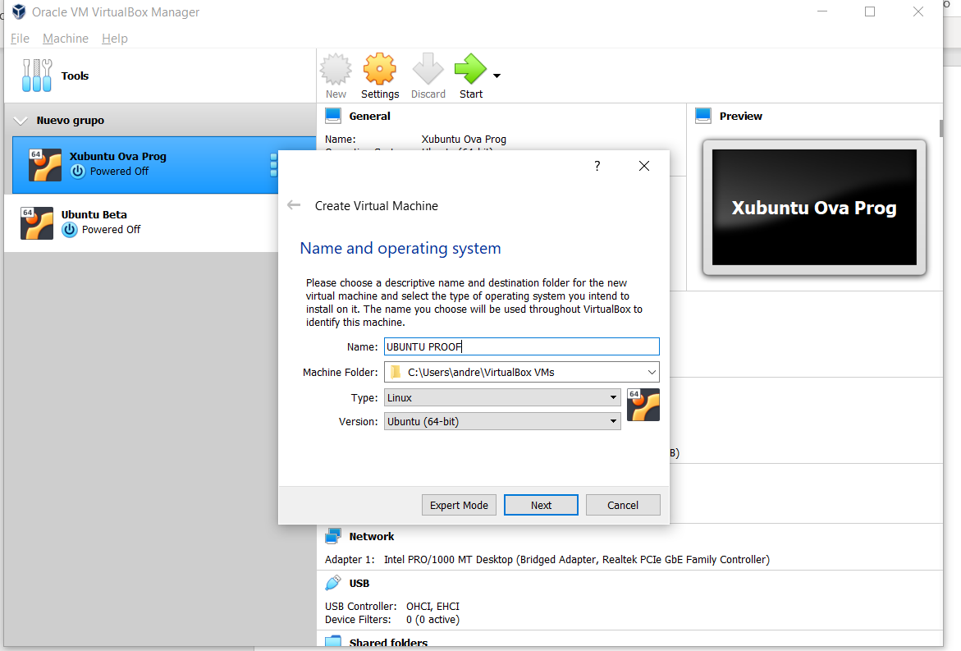

2º THEN WE SELECT THE CAPACITY OF THE RAM THAT WE WILL USE WITH THIS VIRTUAL MACHINE

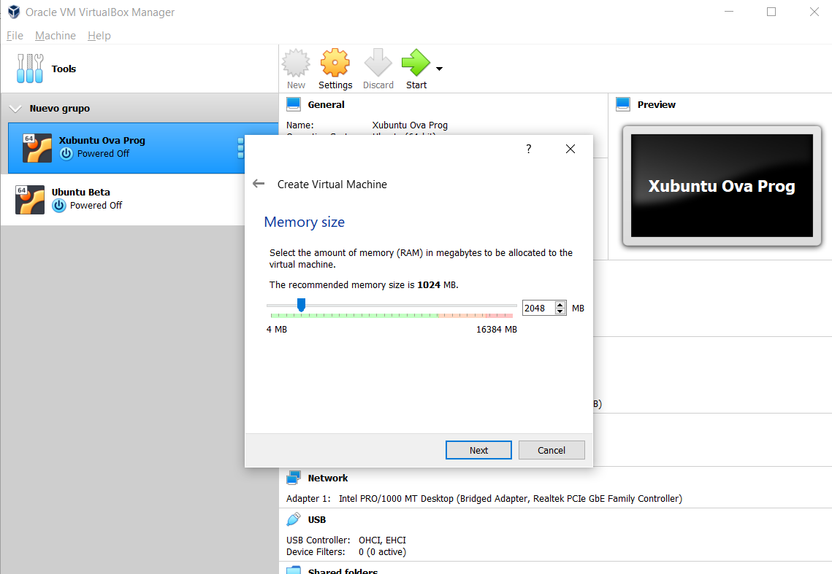

3º THEN WE CHOOSE THE SIZE OF THE DISK THAT WE WILL NEED, IN THIS CASE WE INCREASE TO 30GB

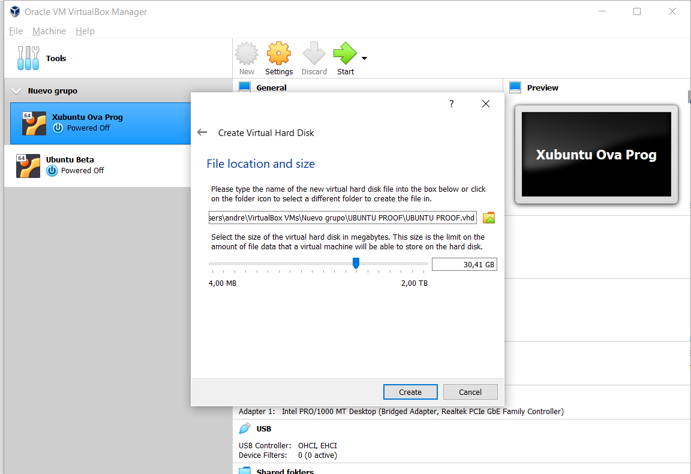

4º WE HAVE TO CHOSE THE PATH OF THE FOLDER THAT WE WANT TO SHARE IN THE SETTINGS MENU/SHARED FOLDERS

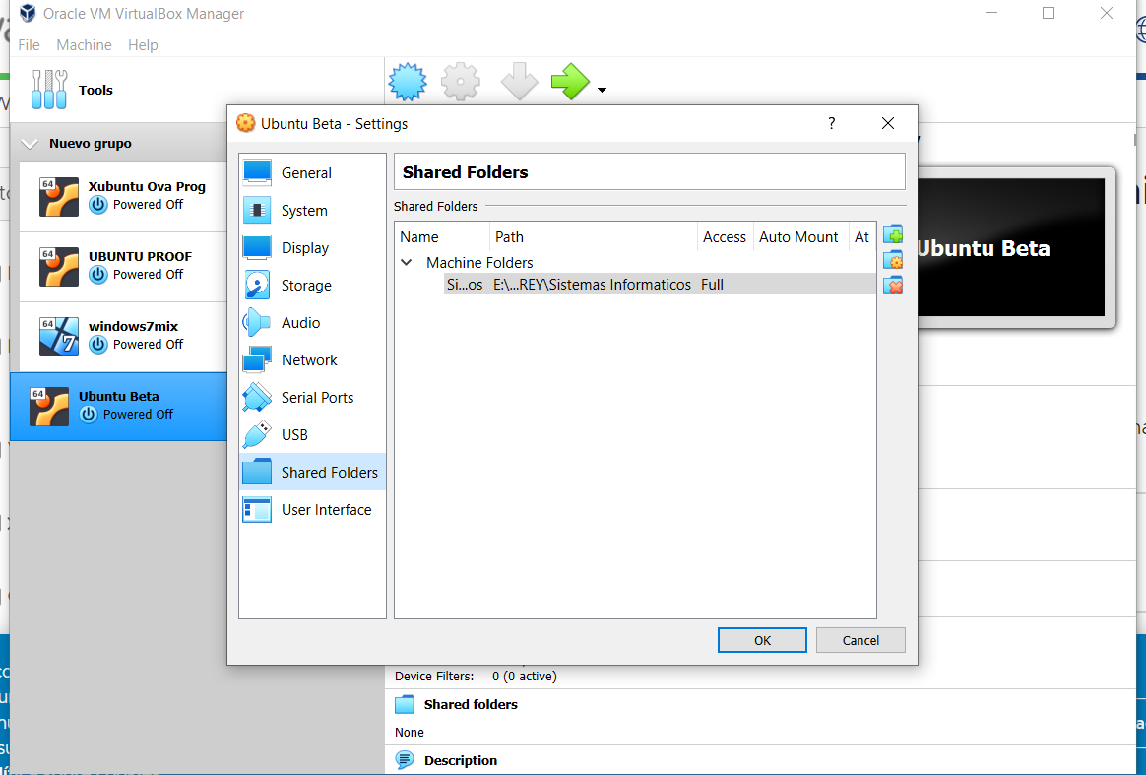

5º AFTER INSTALL IT, WE HACE TO CHANGE THE INTERNET OPTION TO BRIDGE ADAPTER TO AVOID PROBLEMS WHEN WE WANT TO USE IT OUT FROM HOME

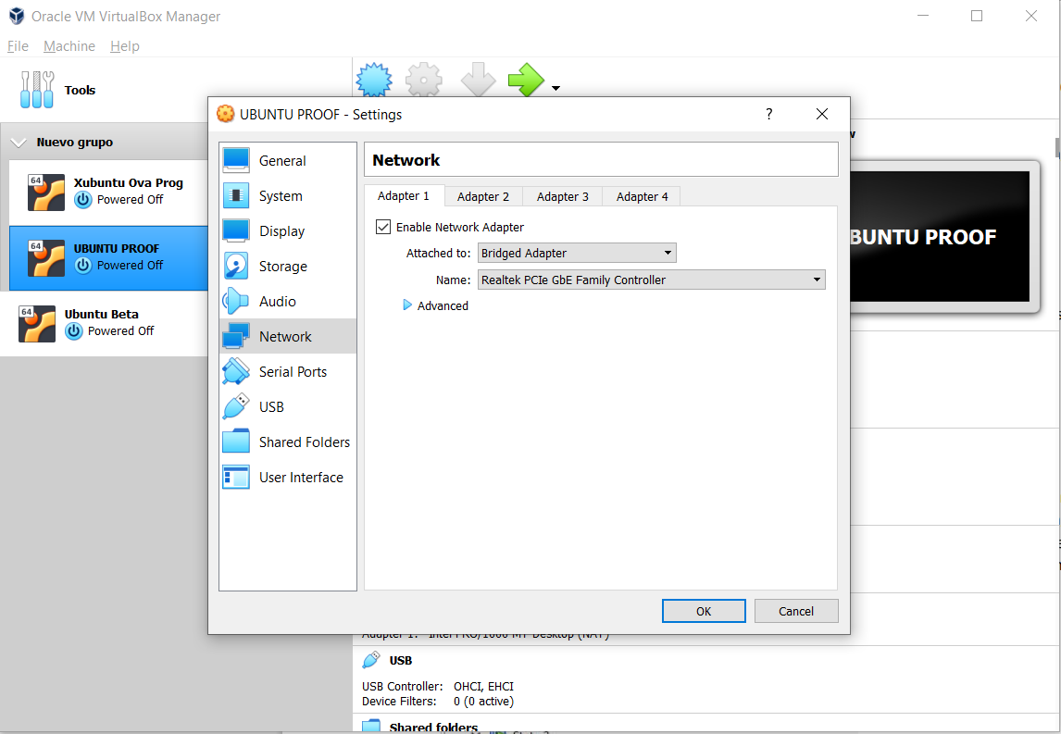

AFTER ALL WE START THE MACHINE TO INSTALL GUEST ADITIONS AND TO CONFIRM THAT EVERYTHING IS OK IN ORDER TO SHARE FOLDERS WITH THE HOST AND THE GUEST

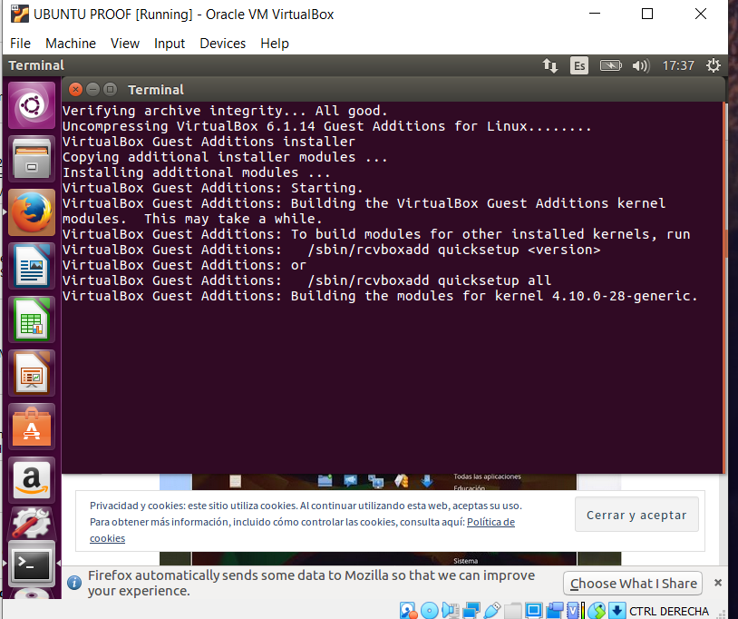

WE ALSO NEED TO HAVE THE SHARED CLIPBOARD IN BIDIRECTIONAL

